San Diego State University
School of Nursing

General Body Meeting Minutes
Date: 9/10/18
Place: Park Blvd Suite
Time: 1610

Attendance: Vyanna Ma, Chloe Jacobsen, Leizl Rodriguez, Sarah Karp, Nicole Perrin, Cristal Vieyra, Tabitha Chua, Kiana Schaubel, Taylor Boden, Kristina Pope, Carissa Fong, Payal Patel, Amairani Grover, Pauline Amog, Blaise Owen, Jenna Fong, Ayda Shamsian, Dr.Kristiana Cullum, Professor Concilio
Excused:
Absent:

Board Member | Topic | Discussion
President:  Vyanna Ma | 9/10 CHHS Council Meeting Report  CNSA Convention  Faculty Meeting Dates  Freshman Nursing Student Orientation  Students HEAL partnership  Workspace @ SLL | October 5-7 in Visalia, CA (9/10 Meeting Report)  -18 registered, 13 delegates!  Tuesdays 1300-1500  September 18, October 23, November 20, December 11  Friday 9/14 3:30-5:30pm @ AH2108  Please complete BOD slide for FNSO!  Reserved AH2108 & AH2122 (Assessment Lab) - Move merch before Fri!  Add to budget: FNSO approx $140 for 11 pizzas  -SNA cord point incentive to attend HEAL fundraiser events?  -Heal fundraisers at our GBM  Office hours Mon-Fri 12-2pm  -1 cord point for coming in  -check in: RedID and state you are here for SNA
Vice President:  Chloe Jacobsen | NSO | Thank you all for your help with making NSO a success!
Treasurer:  Leizl Rodriguez | Budget Report | Budget approved
Secretary:  Sarah Karp | No report
Communications Director:  Nicole Perrin | Vital Signs  Emails | Directors required to write an article per bylaws:  -Image  -Global Initiatives  -email if anyone else would like to write/submit anything  -2 cord points for general members who write  Emails will be sent out Wednesdays.  Post your information by Tuesday at 10pm
Legislative Directors:  Cristal Vieyra | Cohort reps  Resolutions | Freshman Track1 and 2, RN-BSN  -application will be in email blast and due Fri 9/21. Interviews will be done Saturday 9/22 and Sunday 9/23. This will be announced at the next meeting  7 resolutions submitted; still working on final edits with the CNSA board of directors, but it has been approved and published on their website https://cnsa.memberclicks.net/assets/resolution%20proposal.pdf
Community Health Directors:  Tabitha Chua  Kiana Schaubel | Events  Community health meeting | Senior Games  (9/15, 9/16) 4 cord points for a 5 hour shift  Adopt-a-senior  (9/29) 2 cord points for 1 hour  Figuring out when to have the meeting. Possibly after SNA meetings.
Membership/Mentorship Director:  Taylor Boden  Kristina Pope | Bonfire  Membership | Friday at 6:30pm at mission beach  -carpool and bonfire reservation cord point opportunities  -Deadline for application: October 1rst  -date for mentor pairing: October 1rst
Fundraising:  Carissa Fong  Payal Patel | Lanyard Vote  Tote Bags | Voted on design 1  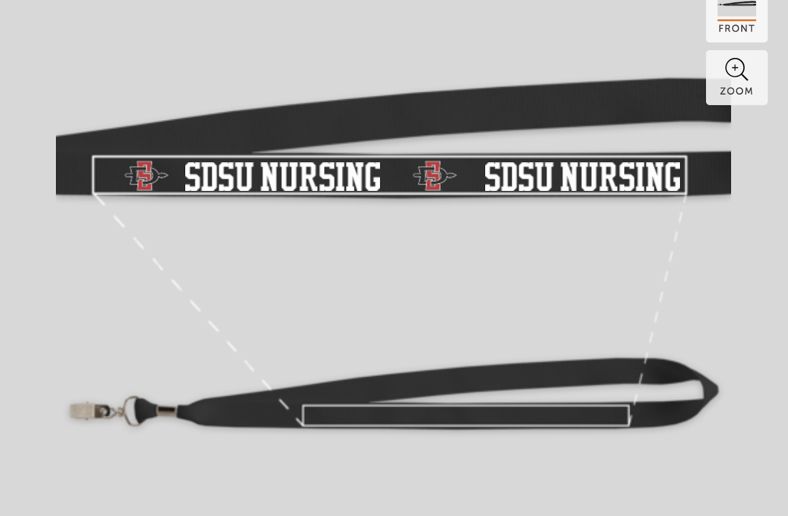  Will sell totes at the next SNA meeting (Venmo and checks preferred)
Global Initiatives Directors:  Amairani Grover  Pauline Amog | Medical Spanish | -waiting for Medical Spanish Teacher  -starts on October 1rst or 15th
BTN Directors:  Blaise Owen  Jenna Fong | BTN Committee meetings  Events | Biweekly Mondays 3pm on same day as SNA outside of student union outside Starbucks  Girl Scouts  09/19, 09/21, 10/04, 10/11  Men In Nursing  11/02 at Grossmont College  Nursing School Presentation  11/6 at Crawford High School
Image of Nursing Director:  Ayda Shamsian | Updates | BOD poster and bulletin board have been updated on Monday 9/10
Faculty Advisors:  Dr. Kristiana Cullum | Conventions  Professor Concilio led events: | -CNSA Convention- 18 attending, 13 delegates  -NSNA Mid-Year (Nov. 8-11, Kentucky)  -Student Success Fee meeting Sept 12 (NSNA April 3-7, Salt Lake City)  -Assessment night  -Medication night  -Lab night  -Opioid epidemic speaker  -incivility night

Motion to adjourn the meeting at 1710
Respectfully submitted by Sarah Karp

