San Diego State University
School of Nursing

General Body Meeting Minutes
Date: 2/17/2020
Place: Pride Suite
Time: 1603-1700

Attendance: Sarah Karp, Tabitha Chua, Kristina Pope, Nikhita Malhotra, Kristina Pope, Hannah Veneracion, Sarah Faucheux, Kasey Bethel, Marcela Chappelle, Brandon Vinzon, Michael Taningco, Irene Ung, Hannah Peeler, Carly Dion, Tara King, Dr. Kristiana Cullum, Professor Concilio
Excused: Nikki Castro, Fernando Garces
Absent:

Board Member | Topic |  | Discussion | Action
President:  Sarah Faucheux | STT Update  CHHS  UPC  Speakers  NSNA Award  One-on-ones |  | STT  - February meeting:  - Event: Life Perspectives March 6th  6-8pm AH2108  $10 for students  CHHS  - New representative: Dannika Chun  UPC  - Representative still needed.  Speakers  - Refugee Youth Mentoring  - 3/2  - Spanish Advisor  - 3/16  NSNA Award reminder  - Fill out convention logistics form by 2/24  One- on- Ones  - In progress, hoping to have them all done by this week.
Vice President:  Kristina Pope | Supplies list  Scrub Fitting |  | Supplies list  - The old one was not accurate to what the labs needed. Samir is talking with the 206 professors to make an updated list.  Scrub Fittings  - Will need people to help run the fittings.  - Will send out more information on this later
Treasurer:  Ashley Jackson | Balance |  | Balance  - Current balance: $49,764.22  - VP: $1,400.00 over approved budget  - Motion to increase VP budget by $1,400.00 approved  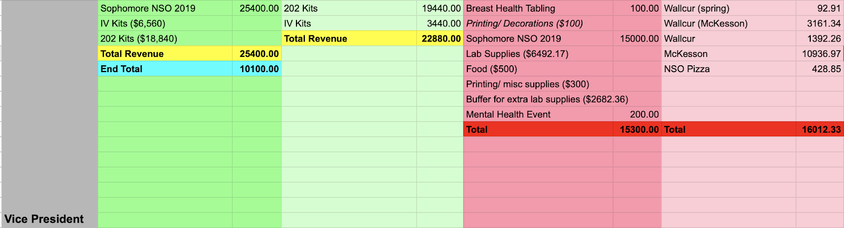
Secretary:  Sarah Karp | No report |  | No report
Communications Director:  Kasey Bethel | Email Signature  Vital Signs  Website |  | Email Signature  - Email signature  - uniformed  - include pronouns and signature  Vital Signs Deadline - April 6th  Update for Website  - Merchandise tab on the website, as well as order form
Legislative Directors:  Tara King | RN-BSN Rep  Thank you  BOD Election | RN-BSN Cohort Representatives  - Three applicants so far!  - Discussing possibility of multiple cohort representatives for RN-BSN  Thank you  - Thank you Michael and Marcela for helping to print certificates!  BOD election  - Application opens 2/21  - Closes 3/6 at 11:59pm  - Speech night 4/6  - We will have a month to find applicants for positions that do not receive any.  - Shadow meeting/ expose to show potential applicants to see how SNA functions  - Image of nursing will create a series of Instagram videos about the positions.  - All board members start to work on handoff binders/ google docs  Bylaws  - Please prepare for the bylaws meeting |  | All BOD work on handoff materials  All BOD prepare for bylaws meeting. Sarah F will send out information regarding meeting date/time.
Community Health Directors:  Michael Taningco  Hannah Veneracion | No report
Membership/Mentorship Director:  Irene Ung  Hannah Peeler | CHHS  Event |  | CHHS Meeting Updates  - Upcoming events  - Explore SDSU  - 3/21 7:30-2pm open house  - More interactive, stamps for visiting 3 tables  - Discover your dream  - Panelists of healthcare professionals  - Mental Health Wellness Fair  - 2/26 10:00am-2:00pm  - Award Banquet  - 5/1 at BJ’s  - CHHS Awards nomination will post in the next 2 weeks  - Stole point program  - Point system for stoles, minimum 15 points, only seniors  - For attending events/meetings/tabling  - Sign and email by 4/10  Event  - Lake Murray Hike  - Friday 2/21 at 9:30am  - Carpool/RSVP sign-ups: https://m.signupgenius.com/#!/showRSVPSignUp/20f0548afaf2ba5fb6-lake  - Everbowl after
Fundraising:  Nikhita Malhotra  Tabitha Chua | Merch |  | Merch  - Orders are open!  - 62 orders so far  - Pinning  - $1000 increase in budget for pinning merchandise, includes $150 fee for tables- approved  - Alumni products  - Board Member Pricing  - Short sleeve: 9.5  - Long sleeve: 12.5  - Gathered sweats: 27.5  - Loose sweats: 18.5  - Crewneck: 30 | Dr. Cullum will process AS check request for tables
Global Initiatives Directors:  Nikki Fernando Garces | Absent  No report
BTN Directors:  Marcela Chappelle  Brandon Vinzon | Events |  | Events  - Career day at O’ Farrel Charter School  - 2/19 9am-11am  - 3 cord points  - Nursing Revealed  - Budget increase of $300 dollars for bathrooms- approved | Theresa Lanzarotto in nursing office will reserve bathrooms and get PO number for SNA to pay
Image of Nursing Director:  Carly Dion | Blood Sugar Rising |  | Interested in a possible SNA-sponsored movie screening?  - BLOOD SUGAR RISING is a two-hour PBS special about diabetes airing on public television on April 15, 2020. The film features in-depth portraits of real Americans living with diabetes, and showcases educators and advocates across the country who are engaged in prevention and management efforts. The film also provides a peek at cutting-edge technologies that may shift diabetes management for years to come. Here is a link to the trailer: Blood Sugar Rising Preview | Blood Sugar Rising  - Ask clinical professors about possible clinical hours  - And here are the next steps to move forward with a screening  - We are hoping for screenings to take place between late February and April, but If not, we can be flexible! Since the film will be broadcast nationwide on PBS on April 15, if you screen it before this date, you can market your event as an "exclusive" screening!  - Once you have your screening date/venue chosen, you can go ahead and complete this Screening Application. Once we receive it, we will send you the film along with a screening toolkit containing promotional materials and a Take Action Guide.  - The film is only available digitally. There is no cost to host a screening.  I will apply for Image of Nursing Award for convention :) | Sarah K will look into the availability of SDSU Theater.
Faculty Advisors:  Dr. Kristiana Cullum | Trans Family Support Services  Bylaws  Rock and Roll Marathon |  | - One of our students spoke with Kathie from Trans Family Support Services and she is very interested in coming back to SDSU to give a presentation. You can reach her at kathie@transfamilysos.org Are we interested in a presentation?  - Marcela is in contact with STT about this  - Website: bylaws  - To find the bylaws on the website it is under committees → legislative  - Bylaws/duties as board members  - all board members review position bylaws  San Diego Rock and Roll Marathon May 31, sign up sheet: https://docs.google.com/spreadsheets/d/1SjccPxZfVTuXNCrLfwkr8nF5BPdWNL2O2eFO3wFNWmw/edit?ts=5e38e75b#gid=0 | Marcela will contact Kathie about this and coordinate with STT  All BOD look at the bylaws and make sure you are fulfilling what is required.

Motion to adjourn the meeting at 1700
Respectfully submitted by Sarah Karp

