San Diego State University
School of Nursing

General Body Meeting Minutes
Date: 2/11/19
Place: Park Blvd Suite
Time: 1600

Attendance: Vyanna Ma, Chloe Jacobsen, Leizl Rodriguez, Sarah Karp, Nicole Perrin, Cristal Vieyra, Tabitha Chua, Kiana Schaubel, Taylor Boden, Kristina Pope, Carissa Fong, Payal Patel, Amairani Grover, Pauline Amog, Blaise Owen, Jenna Fong, Ayda Shamsian, , Professor Concilio
Excused: Dr.Kristiana Cullum
Absent:

Board Member | Topic | Discussion | Action
President:  Vyanna Ma | BOD  Office space  Guest Speakers  Volunteer Opportunity  White Coat  NSNA Convention | 1-on-1 round 2 :)  - Please fill in your availability!  SNA Office Space (Honeycomb Station 1)  - Office hours: Tues & Wed 12-3pm  - Office Hours BOD Sign Up  Guest speakers at meeting:  - TJHB  - DM (Volunteer Form)  - HEAL apps  Volunteer Opportunities:  - Mission Hospice  - Alpha Pi Sigma (latina-based sorority) partnered event?  White Coat Ceremony:  - Thurs 3/14 8-9am  - Chloe, Jenna, Payal, Nicole (maybe), Kristina will be volunteering  NSNA Convention  - Funding recipients announced today  - Discussion - 6 BOD out of 36 applicants  will fund the 6 BOD, and the other 24 spots will be raffled.  - NSNA Awards DUE MARCH 8TH  - Ambassador Award: Recognize a school or state chapter leader! Limit one student per Official NSNA chapter may be nominated.  - Core Value Award: A student that embodies leadership/autonomy, quality education, advocacy, professionalism, care, and diversity. Must be nominated by faculty advisor(s).  - BTN Award: Theme “ Challenging Assumptions: Breaking Barriers, Building a Future”  - Disaster Preparedness Award: Projects can highlight education presentations, development of school or community awareness projects, or disaster-kit preparation. $100 Reward  - Empowering Resolutions Award: If you had an event/project that promoted an NSNA resolution passed within the last 10 years  - Ethics & Governance Award: given to either a state or school chapter which sets up a successful activity (ex. educational program, video on Robert Rules of Order) informing students about their bylaws, policies, and procedures | Board members fill out availability
Vice President:  Chloe Jacobsen | No report
Treasurer:  Leizl Rodriguez | No report
Secretary:  Sarah Karp | No report
Communications Director:  Nicole Perrin | Email blast  Vital signs | - New email blast guidelines were posted on the document. Please read them!  - Vital Signs articles due to me by 4/8!
Legislative Directors:  Cristal Vieyra | Election  Senior Track 2 cohort rep | Time line for elections  - Open SDSU- SNA BOD application in communication blast after meeting on Monday February 25- Tuesday March 12 (day after meeting “last chance to apply”)  - Friday March 15: thank all applicants and send doc to verify applicant will attend speech night  - Speech Night: March 25 (I will not be here)  - Open election ballot in communication blast Monday March 26- Friday April 5 (we will be at convention); Send email to winners Saturday with acceptance by April 8 meeting  - Meeting April 8- announce known winners/ fill positions still needed  - Open fill position application in communication blast April 9-- close Sunday April 14-- send election ballot Monday April 15-- announce filled position at meeting April 22!  New Bylaws are posted on the website!  Vote senior track 2 cohort rep: one application  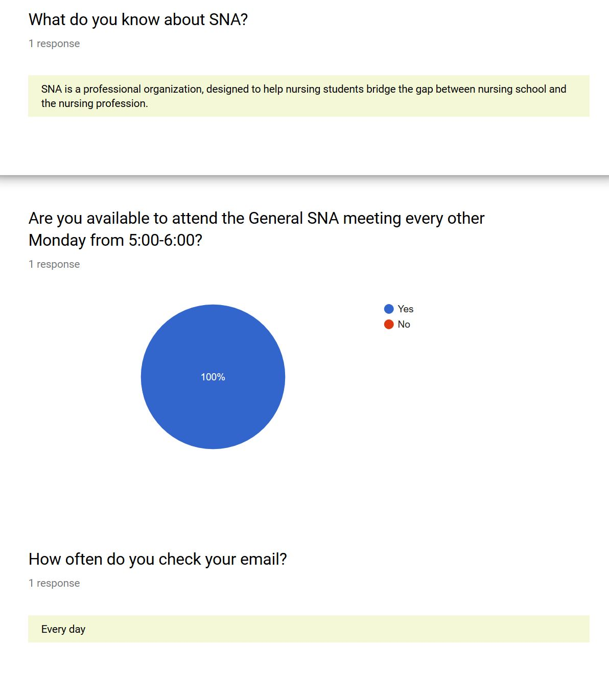  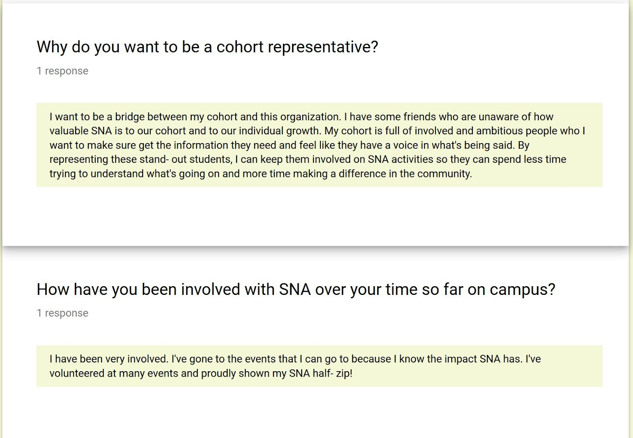  New senior tract 2 representative was approved
Community Health Directors:  Tabitha Chua  Kiana Schaubel | Love Your Heart  Meningitis shot clinic  Semester drive: Lux on her side | Love Your Heart (LYH)  - LYH Training tomorrow at 4:30 in SSW 2650, encourage freshmen to come?  ask the freshman cohort rep to post about this  - If anyone has cuffs/stethoscope that they are willing to let us borrow that would be great!  - LYH 2/14  - Shifts 10-12, 12-2  - Cord points: 2 points per 2 hour shift  Meningitis shot clinic  - 2/20, 2/27, 3/ 5, 3/21 –  track 2 sophmores can do it, possibly some of the track 1 if they have done the injection lab  - cord points: 2 cord points  Lux on Her Side  - 1 package is 1 cord point  - minimum of 20 items in a package.  - 2 points for a box of 36.  - 4 cord points total.
Membership/Mentorship Director:  Taylor Boden  Kristina Pope | Membership  Membership Meeting South | Renew membership if it is expiring!  Membership Meeting South  - Cord points for feminine hygiene drive ? Tabitha is doing this event.  - Cord points for decorating donation boxes  2 big boxes that need to be decorated.  - Pauline and Carissa have been delegated to do this.  -CNSA will be reimbursing  Cord points for MMS volunteers ?  3 cord points for a 3 hour shift
Fundraising:  Carissa Fong  Payal Patel | Chipotle | Chipotle fundraiser  - No march dates open  - Planning for April
Global Initiatives Directors:  Amairani Grover  Pauline Amog | Events | Where Will Nursing Take You  - April 25th  - Trying to find speakers!  Study Abroad Night  - March 21st  Holistic Happy Hour  - April 29th  Global for Global  - Tie dye fundraiser on Feb 28th  - Found an organization: hope through Health, in Togo West Africa.  - cultural menu will be on the website.  Teacher was been found for medical Spanish
BTN Directors:  Blaise Owen  Jenna Fong | High School Presentations  Nursing Revealed  Committee Meeting | High School Presentations  - WE NEED YOUR GUYS HELP  Had a lot of schools respond however Blaise needs people to go. They will need to be the leader of the event, everything is already planned out.  - This helps educate the kids about SDSU  - West Hills Thursday, February 21st 12:17 PM Nicole  - Monte Vista February 25th 10:11-10:47 → Blaise  - Scripps Ranch Wednesday March 13th 11:15-12:17  - Steele Canyon Thursday March 14th or 21st?  - Mount Miguel Thursday, March 21st 1 PM  - Hoover High School: Thursday, March 21st @ 0900  - If anyone can do those dates let Blaise know.  Nursing Revealed  - OFFICIAL DATE: Sunday, April 14th  - Currently finding keynote speaker  - Looking for possible SDSU nursing alumni  - possibly Professor Gonzalez  - Possibly have sim lab open during nursing revealed  Committee meeting  - Tomorrow 5pm  - Outside of starbucks in the student union | Get in contact with Professor Gonzalez about being a keynote speaker.  Speak to Professor Parr about using the sim lab
Image of Nursing Director:  Ayda Shamsian | Giveaway: | Give away for this sememster  - Will have 2 giveaways again  - Any ideas on items: stethoscope, stethoscope holder, badge reels, clinical bag (maybe if fundraising is able to donate one?)  SNA Video link:  https://drive.google.com/open?id=1Olwi09bLV6kDL66NiMIR6--igNNDUQ27
Faculty Advisors:  Dr. Kristiana Cullum | Events | - 2/26 5-7pm Assessment Night or Med Decision-Making Night?  - 3/5 5-7pm Q&A upperclassmen/seniors  - 3/19 7-8:30pm Death & Dying w/ Dr. Madani & Reavis (“an auto complete interview”)  - During meeting, can Vyanna send out a question to the students, “What do you want to know but are afraid to ask about Death and Dying?”  -vyanna will send out a google form. I will take students’ questions and use them as interview questions for the panel.  - 3/26 5-7pm “Code (anything can happen) Night”  obstacle course, stop the bleed section. Need volunteers to be characters  - Dates possibly in March 19th, 20, 22nd starting 5-5:30 “Why should we hire you? Workshop Series” | Vyanna will send out a google doc for the death and dying questions.

Motion to adjourn the meeting at 1700
Respectfully submitted by Sarah Karp

