San Diego State University
School of Nursing

General Body Meeting Minutes
Date: 1/28/19
Place: Park Blvd Suite
Time: 1712

Attendance: Vyanna Ma, Chloe Jacobsen, Leizl Rodriguez, Sarah Karp, Nicole Perrin, Cristal Vieyra, Tabitha Chua, Kiana Schaubel, Taylor Boden, Kristina Pope, Carissa Fong, Payal Patel, Amairani Grover, Pauline Amog, Blaise Owen, Jenna Fong, Ayda Shamsian, Dr.Kristiana Cullum, Professor Concilio
Excused:
Absent:

Board Member | Topic | Discussion | Action
President:  Vyanna Ma | Meetings  NSNA Updates  Bylaws Meeting  Volunteer Opportunities | 1/29 Tues: Recognized Student Organization Focus Group  2/4 Mon: CHHS Student Council Meeting 2-3pm  anyone can go!  2/5 Tues: Health Conference Fundraiser @ Yogurtland  - Leah from health conference committee has planned. 11am-midnight.  - Mention you are there for the fundraiser  CONVENTION  - BOD must fill out as well if interested: https://goo.gl/forms/X3CfhjXeGtVhwgdw1  If you want to write an article for Imprint magazine:  - Deadline 2/4/19  - https://www.nsna.org/get-published-in-imprint.html  Essay Contest:  - Deadline 2/22/19  - https://nsnaawards.weebly.com/essay-contest.html  NSNA Awards  - Please apply for awards if applicable: Deadline 3/8/19  - Please check out the awards you can apply for!  - https://nsnaawards.weebly.com/introduction.html  Potential date:  - 2/4 4-6pm @ park blvd  Mission Hospice  MDA Summer Camp  Alpha Pi Sigma  - (latina-based sorority) partnered event?
Vice President:  Chloe Jacobsen | Supplies | Thank you to Vyanna for helping me with campus lab supplies while I was gone!  I have a box of leftover 202 supplies here for the cabinet in skills lab
Treasurer:  Leizl Rodriguez | Bank Account Details | For the month of December:  Gain: $219  Loss: $620  Balance: $50,000  Don’t forget to make all checks for SNA out to Associated Students
Secretary:  Sarah Karp | No report
Communications Director:  Nicole Perrin | New Logo  Email | Check out the new logo!  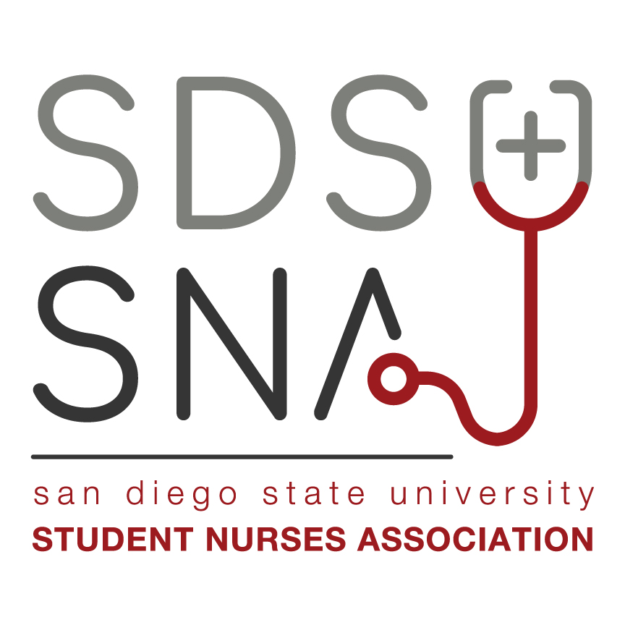  Email blast  - Will be sent out Tuesday evening this semester.  - Please post your information by Tuesday at 12pm!  Website Poll  - Members want more volunteer opportunities and social/bonding events
Legislative Directors:  Cristal Vieyra | Cohort Rep  BOD Elections | Proposal to remove a cohort rep.  Cohort rep kept anonymous  discussion:  - Person has received 5 emails in the past 3 months, acceptance to position was the only email responded to.  - Duties have not been fulfilled  - 2 November posts, 1 December post missed  - Missed 2 meetings, have not made it up  - Have not gone to an event  - Crystal has exact detailed dates/emails if anyone wants to see  - Believes this person should not be a cohort rep  - motion to postpone vote: denied  - vote for removal: 10:2  - passed  - Crystal will talk to them today about this after the meeting, if not there she will email.  - applications will be sent out tomorrow for the new cohort rep  Will not be here on the meeting of 3/25 due to the conference
Community Health Directors:  Tabitha Chua  Kiana Schaubel | Events  CH meetings | Love your Heart 2/14  - trying to get this on campus, they have it all over SD  - Love your Heart Training on 2/05 at 4:30  Semester Long drive  CH meetings start 2/05 at 4:30pm
Membership/Mentorship Director:  Taylor Boden  Kristina Pope | Project InTouch | Project InTouch  - Deadline is 2/06  - Applications were sent in last semester  - Will have new applications today
Fundraising:  Carissa Fong  Payal Patel | Holiday grams  Merch | Holiday grams  - Raised $150  - Cost was around the same amount  - Will give $150 to the health conference  Will be distributing more merch today
Global Initiatives Directors:  Amairani Grover  Pauline Amog | Speakers  Global for Global  Cultural Menus | Medical Spanish  - Need to find 2 medical Spanish teachers  Where Will Nursing Take You (WWNTY)  - Need to find speakers for this  Work with Fundraising for new event: “Global for Global”  - Finding non-profit organizations in Africa  - Still deciding on an organization  - Will have a tie-die fundraiser and send money to organization  Saw this at CNSA convention, want to incorporate this in our website | Find speakers for WWNTY and Medical Spanish clas.
BTN Directors:  Blaise Owen  Jenna Fong | Assassins Fundraiser  Presentations  CH Collab  Nursing Revealed  Committee meeting  Mannequins | Assassins Fundraiser  - Game  - 10$ per team  - A team goes after B, B goes after C, C goes after A.  - shoot with water guns, need to wear a floaty for protection  - can be a fundraiser in SON  - -semester long game  - at Blaise’s high school they raised around $700  - raising money for SNA, half goes to SNA, half for team who wins  - discussion to change this to spoons instead  - if this is done we would have to hold the money because we couldn’t deposit it into AS and then take it our for the winner  - Blaise will look more into this  Presentations  - Will be contacting high schools  Collaboration with CH to do CPR Block Party  Revealed  - Date TBD, in April  - Still need to find a keynote speaker  - Let us know if you have any ideas  Committee meetings  - Tuesdays @5pm  - Opposite Tuesdays of CH  Where can I put them?  - Dr. Cullum will check with SON | Blaise will look more into this game and will come to the next meeting with more details.  Contact high schools  Find a keynote speaker and figure out the date for nursing revealed  Dr. Cullum will figure out where to put te mannequins
Image of Nursing Director:  Ayda Shamsian | Video Project | Video project is done!  - Just waiting for approval and I will share it at the next general meeting!
Faculty Advisors:  Dr. Kristiana Cullum | Schedule number  Professor Concilio events  Updates | The schedule number the students will need to enroll for 1 unit of NURS499 is 290866  Events for spring semester with Prof. Concilio  - Assessment night  - Med night  - Why should we hire you workshops  - 5 part workshop series, so we can have smaller groups to help people market themselves.  - sign-ups, preferential to people graduating  - Death and dying with Dr. Madani and Dr. Reevis. March 19th at 7pm  - Younger students ask questions to the older students  SDSU Leadership Summit Feb. 16, 9-3:30  Explore SDSU March 23,  - sim lab will be open.  - Prof. Parr would like volunteers.  - She will let us know how many for the day and we can do a sign up for shifts  Swiss students (June 15-July 5)  - Monday, July 1-Padres game  - Tuesday, June 18- What is SNA
CNSA  Kristina Pope | MMS | Volunteers for MMS  - Will ask members to volunteer in email blast  Purchase parking in bulk?  - This will have to be done through the university, will have to buy off all the spaces.  - Talk to event services  Special CNSA cords  - CNSA has cords that chapters use, are we interested in switching over to theirs.  Tables and chairs for MMS  - talk to SLL  - Need to talk to SLL for approval for tabling and for vendors. Speak with SLL,  - Send list to Vyanna and she can ask SLL

Motion to adjourn the meeting at 1504
Respectfully submitted by Sarah Karp

